Pedram Sharif

SER-421 Gary

Activity 2

http://www.cbsnews.com

Response Header from Tamper Data:

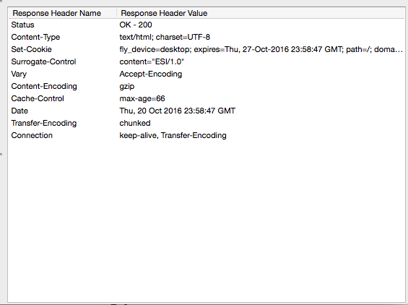

1.) Does the site set a cookie?

Yes. Next to the Set-Cookie Header are the cookies the browser should remember.

2.) Does the site use persistent connections?

Yes. The connection type is keep-alive, which means the site can handle persistent connections and this is the default setting.

3.) Does the site compress its content?

Yes. Content encoding is gzip which is a form of compression for the content on the website.

https://search.yahoo.com/ (Searched Walnuts)

Response Header from Firebug:

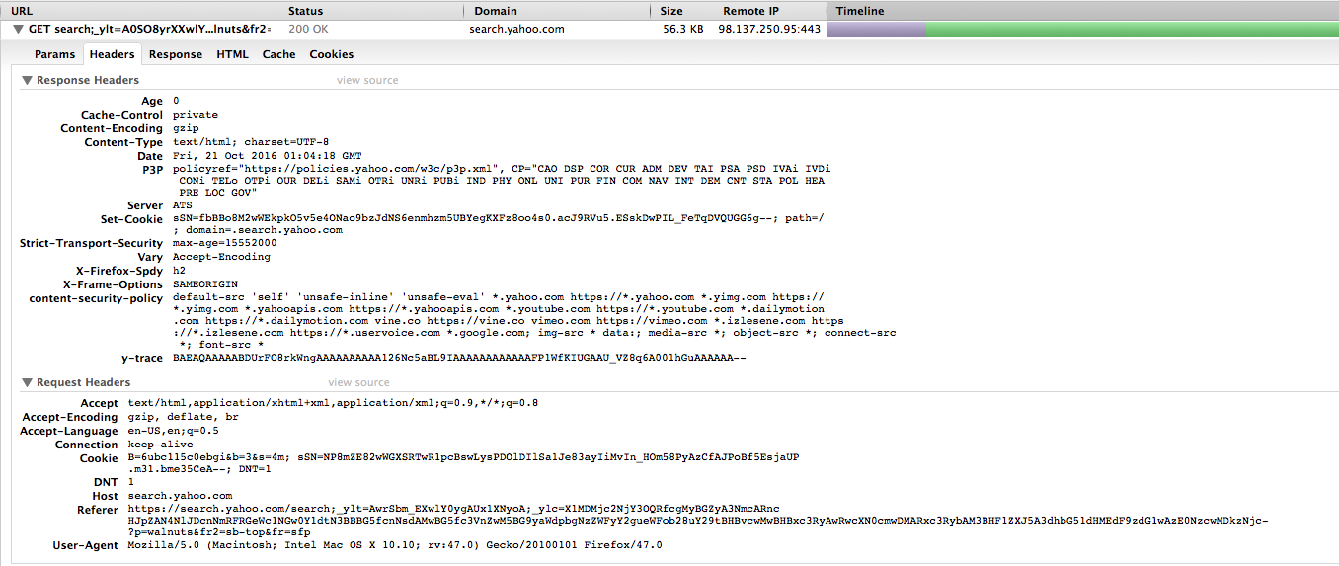

1.) Does the site set a cookie?

Yes. Next to the Set-Cookie Header are the cookies the browser should remember.

2.) Does the site use persistent connections?

The connection type is keep-alive in the request headers.

3.) Does the site compress its content?

Yes. Content encoding is gzip which is a form of compression for the content on the website.